Socialism

Game Design Document made by:

Alvin Aby Artahsasta - 210164398

Andreas Wijaya – 2101656641

Fajar Ibrah Muhammad - 2101674751

Felix Yustian – 2101658275

Pires Cerullo - 2101689841

Contents

**Overview**3

Theme / Setting / Genre 3

Core Gameplay Mechanics Brief 3

Targeted platforms 3

Project Scope 3

Influences (Brief) 4

Project Description (Brief): 8

Project Description (Detailed) 8

Core Gameplay Mechanics (Detailed) 8

- <Core Gameplay Mechanic #1> 8

**Story and Gameplay**9

Story (Brief) 9

Story (Detailed) 9

Gameplay (Brief) 14

Gameplay (Detailed) 14

**Assets Needed**14

- 2D 15

- Sound 15

# 

# **Overview**

## **Theme / Setting / Genre**

Typing, Adventure

## **Core Gameplay Mechanics Brief**

- Explore dungeon, mengetik untuk melawan musuh

## **Targeted platforms**

- PC

**Monetization**

- In game purchase

## **Project Scope**

- 6 bulan

- <Team Size>

- <Core Team>

- Alvin Aby Artahsasta

- Andreas Wijaya

- Fajar Ibrah Muhammad

- Felix Yustian

- Pires Cerullo

## **Influences (Brief)**

1. **Game: Typing of the Dead:** This game is a modification of a game called House of the Dead, it gives us inspiration and reference of our gameplay which is typing as a form of attack.

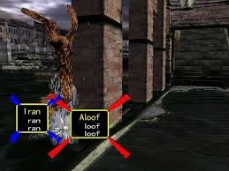

1. **Web Game: Typeracer:‌** This a form of popular internet competition, the contender must type a paragraph as fast as possible to win.

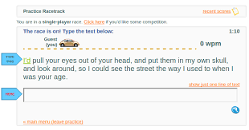

1. **Game: Epistory:** this game has adventure genre with typing battle mechanic. This game is so challenging and fun at the same time, that’s why we decided to use it as preference.

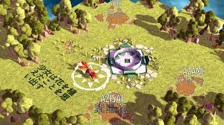

1. **Metal Gear Solid:** This game inspired us in the story area, which includes, social engineering, conspiracies, existentialism, and postmodernism.

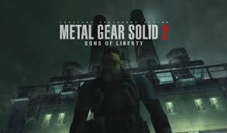

1. **Shin Megami Tensei:** Reference the world setting, which is apocalyptic, and false gods.

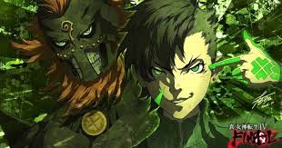

1. **#140 Characters:** This movie is a documentary about Twitter, we use this because of how bad this movie is, making us using twitter as the 1st boss.



1. **Kingsman:** Inspired us in terms of controlling society and making them mad or crazy.



1. **The matrix:** basically because it’s the of reference about the digital world consisting of data and matrix.



1. **Final Fantasy:** Every RPG will somewhat reference a Final Fantasy game.

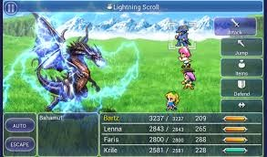

1. **Black Mirror:** This series explores the idea of some form of consequences in overusing and dependant on technologies, and in this case we focus on social media.



## **Project Description (Brief):**

Socialism adalah game dengan genre adventure dengan battle system typing. Game ini memiliki perspective third person dengan kamera top down (player melihat karakter dari atas ke bawah). Socialism memiliki latar belakang dunia masa depan dimana aktivitas sosial media semakin kacau dan tidak terkendali, membuat seluruh orang menjadi budak sosial media. Story game kami berawal dari seorang remaja yang menjadi salah satu korban sosial media, ia tersadar setelah ponsel yang ia gunakan terjatuh.

## **Project Description (Detailed)**

Kami memulai project ini dengan membuat story game, kami menciptakan story berdasarkan kondisi interaksi masyarakat di Indonesia. Saat ini masyarakat cenderung kurang berinteraksi antara satu dengan yang lainnya, hal ini tentu menarik perhatian kami untuk menciptakan suatu game yang bisa memberikan pesan yang baik bagi pemain.

Player bisa menelusuri stage pertama game dengan mengendalikan karakter menggunakan keyboard atau mouse. Pada saat player menelusuri game, player akan dihadapi oleh beberapa musuh yang ada di stage tersebut, dalam stage ini player akan memasuki battle system. Battle system game ini adalah ‘Typing to Attack’, dimana pada bagian atas musuh akan ada kata-kata yang harus diketik oleh player. Untuk melakukan serangan, player harus melengkapi kata-kata tersebut dengan benar.

Game kami merupakan top-down Role-Play-Game yang berbasis 2D. Software yang kami gunakan untuk menciptakan game ini adalah Unity, serta kami menggunakan RPG Maker untuk mendesain stage (level) game kami.

## **Core Gameplay Mechanics (Detailed)**

### **- <Core Gameplay Mechanic #1>**

Untuk menggerakan Character:

* Player dapat menggunakan arrow key
* Player dapat menggunakan left click dari mouse

**- <Core Gameplay Mechanic #2>**

Untuk melakukan serangan ke musuh, player harus menggunakan keyboard untuk mengetik sesuai dengan kata yang ada di bagian atas musuh.

# **Story and Gameplay**

## **Story (Brief)**

December 19th, 2040, the world as we know has changed, unlike what people imagined, there is no world war, no asteroids, no zombie apocalypse, something else has made the world a dystopia, something we, humans, created ourselves.

## **Story (Detailed)**

[PROTAG INTRO]

   A boy woke up from his deep sleep, trying to reach his phone. There isn’t anything else besides human necessities and twitter. Feels like nothing else matters anymore besides the screen in front of him, almost like he was brainwashed. Likes, retweets, and comments thrown with no emotion behind it.

   He felt hunger, so he goes to the kitchen and reach for something from the fridge. He senses a big earthquake and drops his phone to the floor, breaking the phone.

*"…"*

   The boy appears confused, he doesn't know what to do without his phone.

   Almost 2 hours has passed since then and he still just stands there. Finally, he regained his long lost senses, and felt a tremendous need to see his parents, he goes to the living room to see that his parents, just sits on the couch with their eyes glued to their phones.

*"Mom!!, Dad!!"* as he calls his parents.

   he tried to call them, even shake them, but they won’t budge. He felt scared and ran out of his house, only to realize that everyone in the area is the same, glued to their phones without any care of their surroundings.

(transition)

[WORLD SITUATION]

   The boy felt the desire to investigate the situation further, so he heads to the downtown area, only to see the same thing, and one more thing that every billboard, big or small, all displaying one thing, that is ads for facebook. The boy continues his search until he saw a girl without a phone goes into an alley, He immediately ran to the alley, as he caught up with the girl he tries to get her attention.

*“Hey, you!! can you tell me what is going on here?” as the boy yells to get her attention.*

*The girl almost jump, as if she saw a ghost.*

*“Y…You!, who are you?!” her voice was shaking a lot, as she prepares to run from the boy.*

*“Calm down, please don’t run! I need to know what happened to this city”.*

*…“Wait, you don’t have a phone or any devices with you, are you speaking on your own will?” she asks as if it was a strange thing.*

*With a calming voice, he says, “Of course I am, I know something wrong happened here, and I think both you and I are in the same situation”.*

   “*Finally, it’s been so long since I meet and talk to someone*” *as she tears up and cries.*

The boy just walks towards her and give her a hug and a pat on her back, thinking that whatever that she been enduring all this time must be so tough for her.

   After she calms down the boy asks her once again about what happened. The girl tells him about what she knows, she said that she also regained her senses about 2 years ago and all that happened here was caused by a new entity that manifested, they’re the social media. Those once digital entity has got a physical godlike form and power, they brainwash the society to only think about social media, which gives them power to rule.

*“…”*

*“I know these things look like some kind of bad fanfiction, but if you look around, it wasn’t that farfetched.” says the girl.*

*“After all gods only manifested if someone believes or worships them and since people already glued to their social media even before the brainwash, no wonder they got their physical form”.*

*“I guess so, aight I trust you, so what do we do now?” asks the boy.*

*“Nothing, we can’t do anything about it, they got everyone even the police and the military on the palm of their hands”.*

*“What?!, hell no! I’m not going to let them corrupt society any further! And I for sure not going to be a senseless mindless bot again” the boy speaks with anger and conviction.*

*“YOU CAN’T!… What if you die?!… you are the first and only normal person I’ve ever met in these 2 years, I don’t wanna be alone anymore…” she said that while holding back her tears.*

*“I can’t let this ‘gods’, or should I say ‘demons’ do this, we are the only ones that can do it, I’m going whether you coming or not,” says him as he walks away.*

*After taking a deep breath she spoke, “AAAARGH! SCREW IT, I’m going too, I don’t wanna live like this anymore! if we die, we die!”*

*As he smiles the boy says, “Glad to have you, partner, I need your experience after all”.*

[TWITTER]

   The two of them begin their journey to destroy the false gods. The first one to defeat will be twitter which nest in their city, they know just killing the social media won’t be enough, because as long as they have influences on people they’ll keep reviving. The girl thought of a plan, but it won’t be easy, she knows that every social media has made a building their fortresses, not only that, these buildings also act as a server, so just like any program that requires network, you bust the server you bust the connection.

   To get inside the building, they will need to be very sneaky and ready for a fight because when you go inside the building, the chances are they’ll know, not only the controlled police and military, you’ll also fight the manifestation of the social media itself, then destroy the servers.

   As for the weapon, you’ll use a smartphone, if used correctly it can be an effective weapon, their real form is just collections of data after all. For Twitter, you’ll need to tweet, the bigger and harder the word the bigger the damage.

   So sets out the two of them to the building.

*Sneaking in front of the building the boy said, “so what do we do to slip through the gate?”.*

*“Don’t worry, this is the easiest part, you know the quote ‘when in Rome do as the Romans do’?”, says the girl while smirking.*

*“…What?!” says the boy in confusion.*

*“Here, you know what to do don’t you” as the girl give him a smartphone.*

*“ooooooooowh” the boy understood what she meant.*

So they try to act innocent and glued their eyes to their blank phone screen, it was a free pass to the entrance, and the girl knows that the security will be sloppy till the 50th floor, it was a breeze, but since there are 140 floors, there are still a lot to go. The challenge starts at floor 51, and at floor 60 fighting the guards was inevitable.

   (Floor 60)

*“shit they noticed us!” says the boy as he prepares to fight.*

*“Don’t worry, I’m ready!” as the girl unlock the smartphone.*

   Using batons, the guards try to hit them, and the two of them keep dodging and evading a fatal blow, while also tweeting from their phones until the guard errors out and froze, this pattern continues floor by floor, getting harder every 20 level.

   (Floor 120)

*After a tweet, the boy realizes, “Oi, normal words won’t work on them anymore! Give a hard word?”.*

*“use pneumonoultramicroscopicsilicovolcanoconiosis!” says the girl.*

*“what the frick is that!”.*

*“it’s a lung disease, just shut up and use it!”.*

*“Ok, I’ll try that!” says the boy while trying to tweet that word*

*That word one shot the 120th-floor guard on half health.*

*“well, I need to remember how to type that word, whatever that is” as the boy surprised by the damage.*

*(Floor 139)*

This will be the floor with twitter on it, both of them look nervous but ready at the same time, knowing this will make it or break it, everyone lives in this city rest on their exhausted shoulder.

*“Finally…” says the boy.*

*“Yeah”.*

*“I used to avoid people and use social media all the time, now I’m gonna destroy one of them hahaha!” says the girl laughing.*

*“If we win and make it through, let’s hang out,” says the boy*

*“Sure, I think I’ll lay off of the internet and socialize a bit after all hahaha!”.*

After sharing a laugh and getting ready for the boss fight, the elevator opens up. It was a huge room and in the middle stands what could be none other than twitter, manifested as part bird part man-creature as if he was Egyptian deity “Horus”, and from the information that the girl got, his power is to materialize word.

*“LOOK AT YOU IDIOTS TRYING TO BE A HERO, I THOUGHT YOU’LL NEVER REACH THIS FLOOR, DON’T THINK THAT I’M AS WEAK AS THE HUMAN GUARDS, I…AM…A…GOD!!!, BOW BEFORE ME!!!, HAHAHAHAHAHA!!!” says twitter with its unpleasant voice.*

*“I don’t care what you are…, one thing for sure, us humans making you was a mistake, and you’re going down,” says the boy with determination and fire in his eyes.*

The fight between them begins, both party uses every single words they know, twitter materialized word was hard to evade and damage them quite heavily, the humans is close to running out of words while the attack keep coming, they know that their words damage him quite heavily too, but it's not enough even after the boy use the same word on 120th-floor.

   “Don’t you have like a trump card or something?!” the boy yells to the girl.

   “I might have one! but it's really hard and long to type!”.

   “Just type it right now, I’ll distract him and make me his target” as the boy ran towards twitter.

   The boy evades and tanks every single attack while protecting the girl, and the girl keeps focusing on the word knowing whatever happened to the boy she has to tweet it.

   The boy is on the verge of collapsing when twitter materialize something enormous.

*“ENOUGH PLAYING AROUND, I KNOW THE GIRL HAS BEEN SETTING UP SOMETHING, MIGHT AS WELL KILL HER NOW HAHAHAHAHA!”*

*“TRAIN!!” says twitter.*

Every last ounce of the boy strength was put to run to save the girl, he jumps in front of the approaching train and pushes her aside, he know she is saved, but there is no hope for him, so he closes his eyes and accepts his death.

*“…”.*

   The boy hit the floor, confused as of what happened. He opens his eyes and saw the train stopped, so he immediately look towards the girl.

*“I…did…it,” says the girl in disbelieve, almost whispering to herself*

*The train and twitter has froze and disappears into nothingness.*

*“wait…we won?!” says the boys lying on the floor.*

*He says to the girl, “You did it!!”.*

*“No…, WE did it!”.*

*“Well this is quite anticlimactic, I was going for a more dramatic ending for this fight, but I guess this works HAHAHAHAHA!” says him while laughing hard.*

*“You better be glad that you’re alive, you promised to hang out with me”.*

*“Well I’ve said it, but don’t remember making a promise HAHAHA!”*

*“Enough joking around, let’s go destroy the server, I don’t want him to be revived and do this all over again,” she said that with a tired smile.*

*“Yeah, you’re right”.*

   So they destroyed the server, rest a little bit then go outside the building feeling joyous seeing people outside get their senses back again. Only to realizes it later that they only save one city, and there are more city to save.

## **Gameplay (Brief)**

Berjalan untuk mengexplore sebuah stage dan menyerang musuh yang mendekati character dengan cara mengetik. Setelah player berhasil menyelesaikan stage tersebut, player akan melanjutkan ke stage berikutnya.

## **Gameplay (Detailed)**

Untuk melaju ke stage/level berikutnya player harus dapat meng-explore level yang sedang dijalani secara teliti. Player bisa saja menemukan key atau kunci yang terletak di suatu tempat pada level yang sedang dimainkan, dan bisa saja kunci tersebut membuka suatu pintu yang tidak dapat dibuka sebelumnya. Selain itu player juga dapat bertemu dengan boss dan harus mengalahkan boss terlebih dahulu untuk melanjutkan ke level berikutnya.

# **Assets Needed**

## **- 2D**

- Video or Gif untuk background menu.

- Sprites Character and enemy

- Tilesets

- Animation

## **- Sound**

- Main menu theme song

- Sound effect

- Attack SE

- Foot Steep SE

- Background Music

- Main menu BGM

- In-game BGM

**Screenshots:**

* Preparing basic assets such as character etc
  + This sprites was made by photoshop

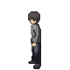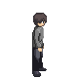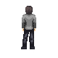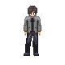

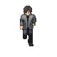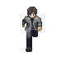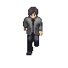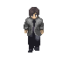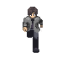

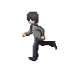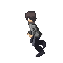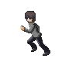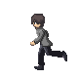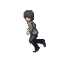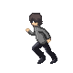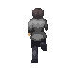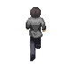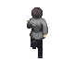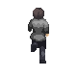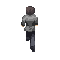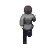

* + This sprites was made by Aseprites



* 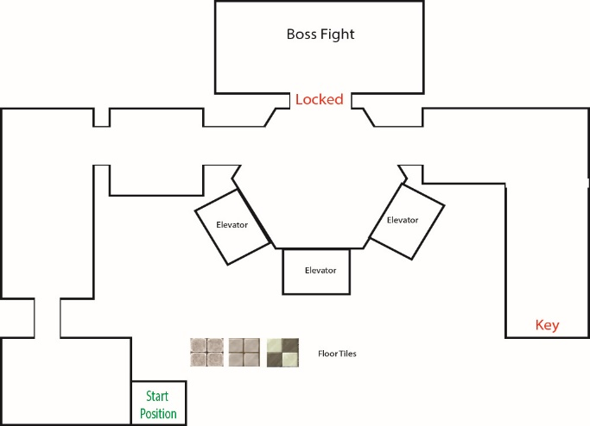Creating Level map with Adobe illustrator

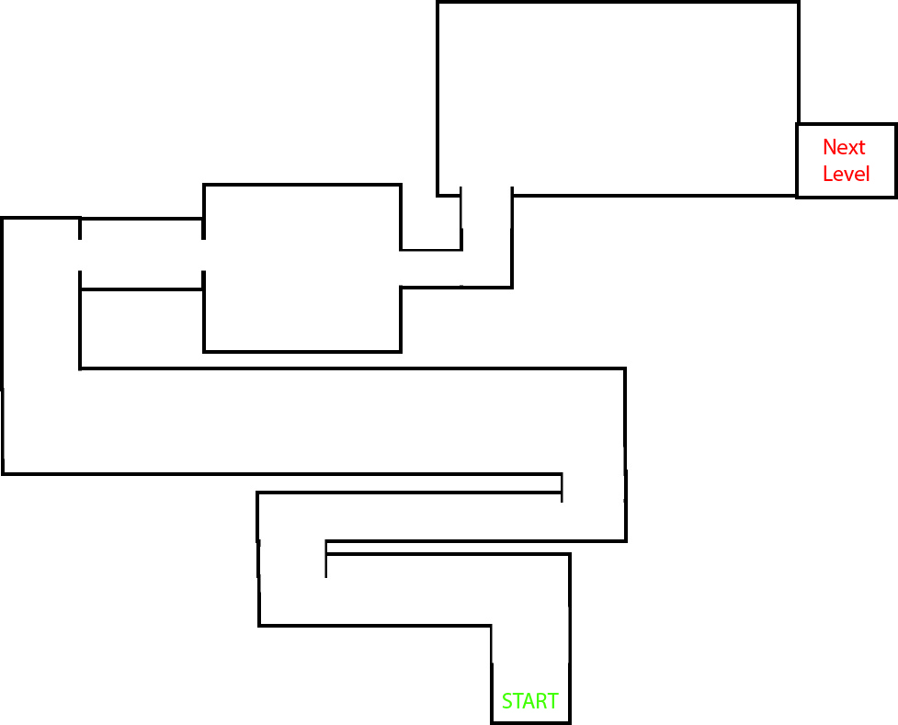

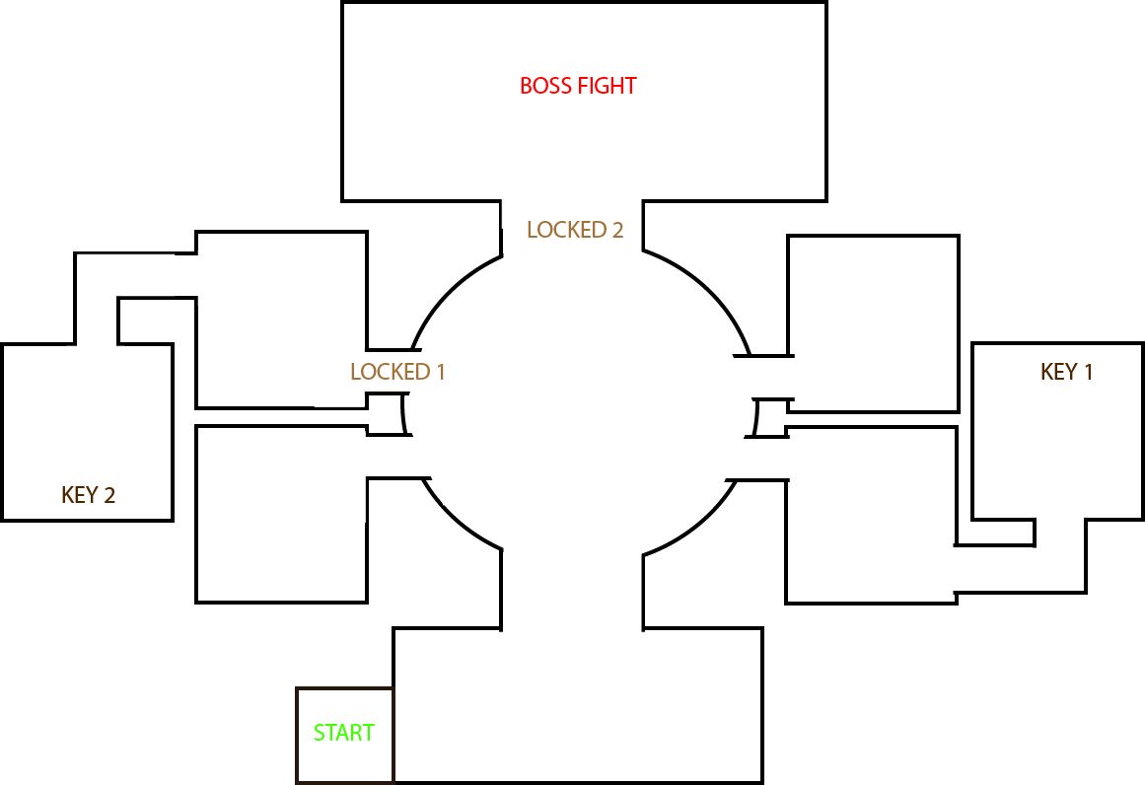

* Make the map with RPG maker

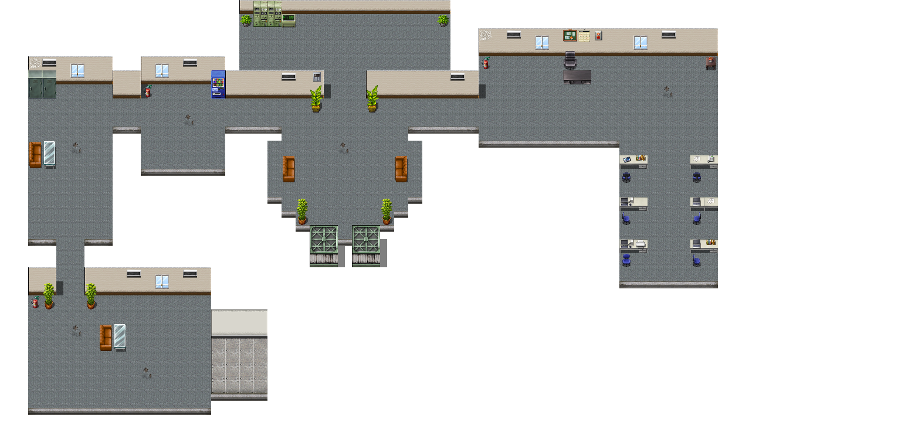

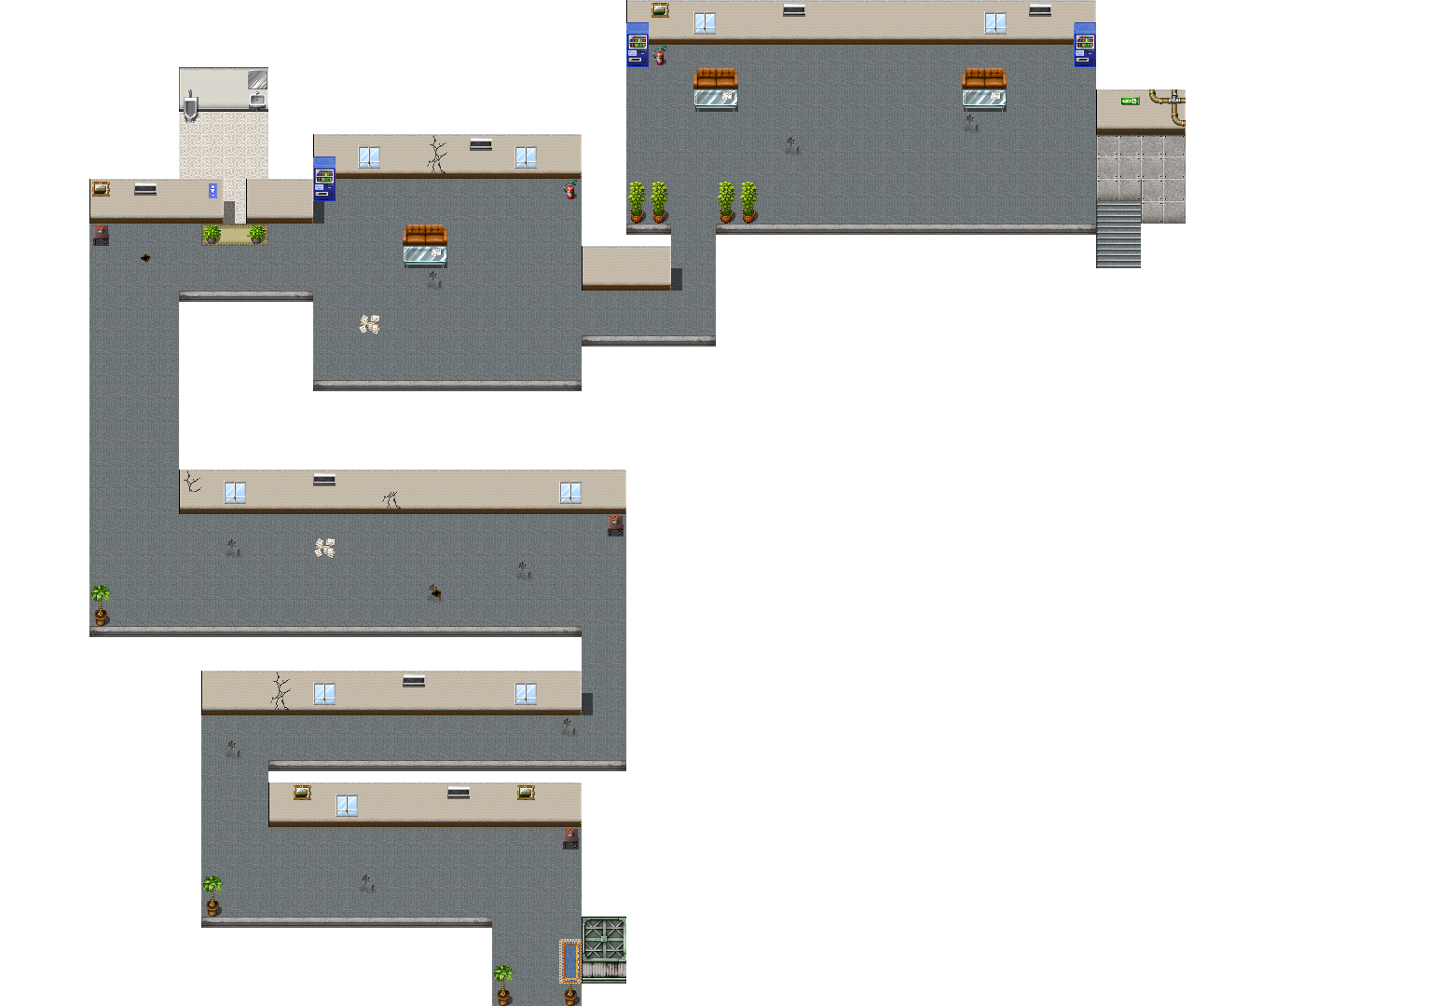

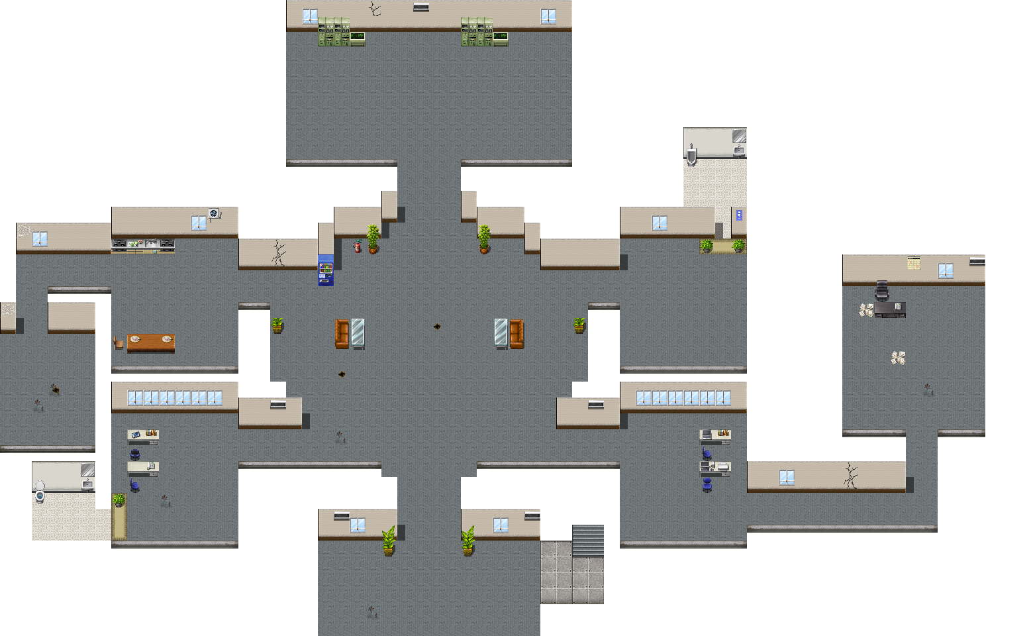

* 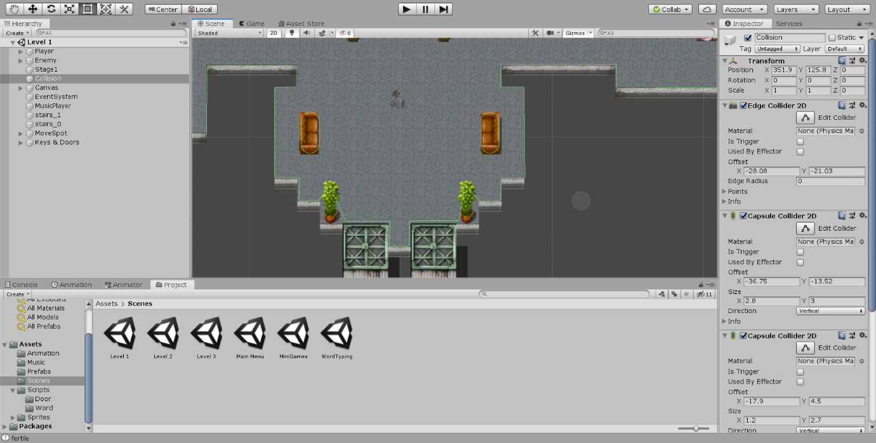Add Collision to the map
* Start making player controller and AI for Enemy

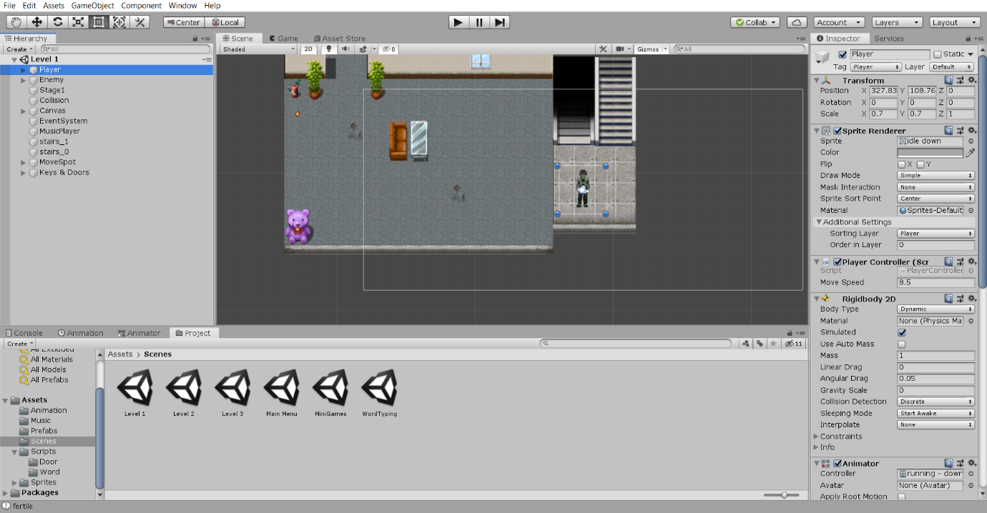

* 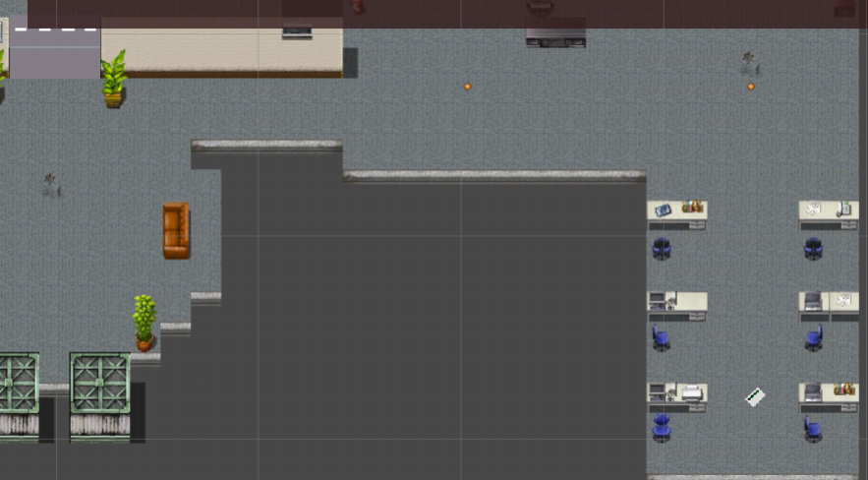Add keys and doors
* 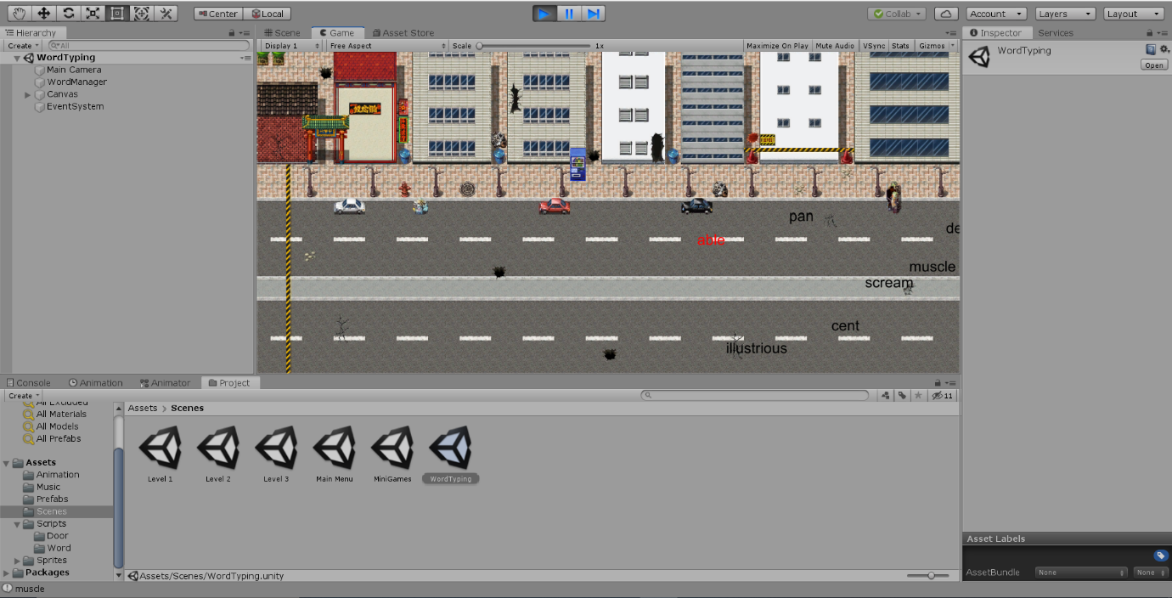Make the Typing Mechanic
* 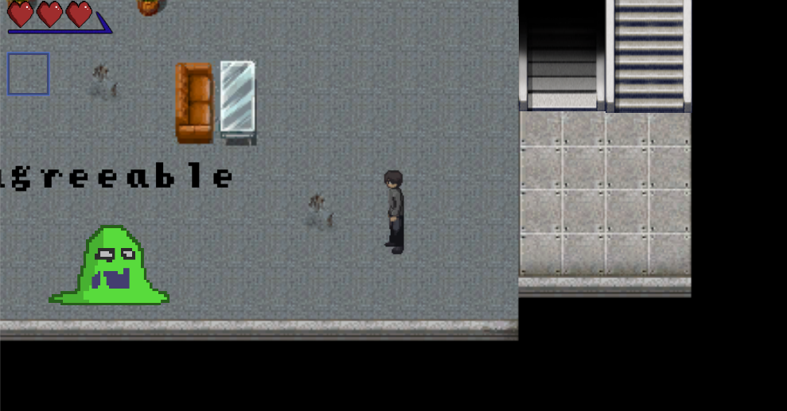Implement Typing mechanic to enemy
* Create poster and trailer

We are not satisfied, so we decided to remake the poster and trailer

* Add some more sprites that’s still needed
  + Player Attack sprites made with photoshop

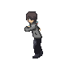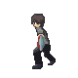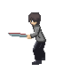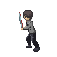

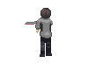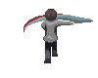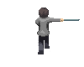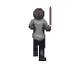

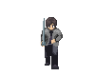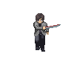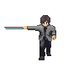

* + Door sprites made with Aseprites:



* + UI that tells player if player has key made with Asesprites:



* 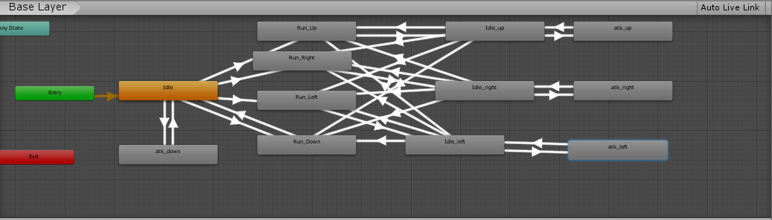Improve the animation
* Some more sprites

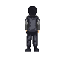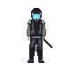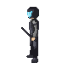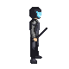

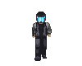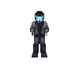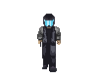

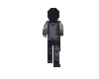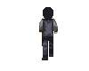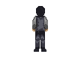

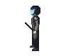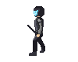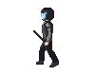

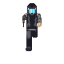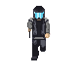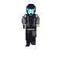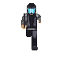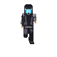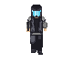

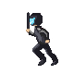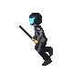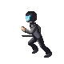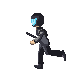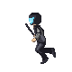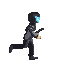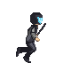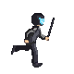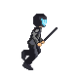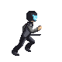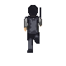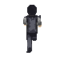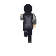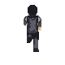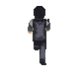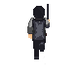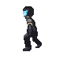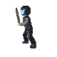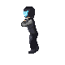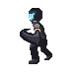

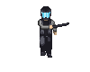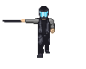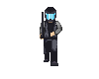

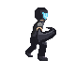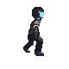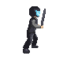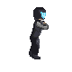

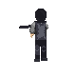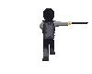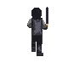

* 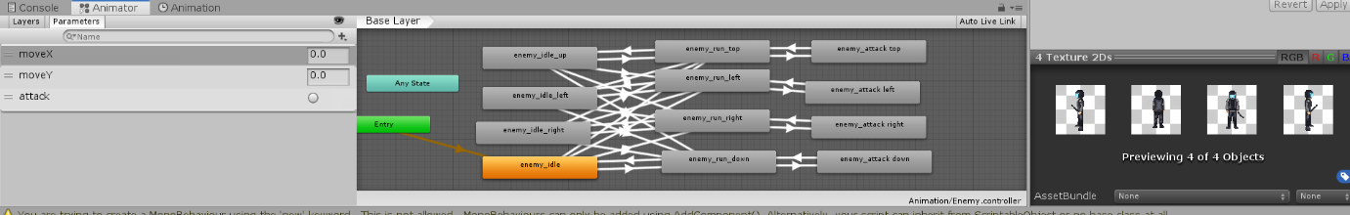Thats mean more animation
* Remake Poster

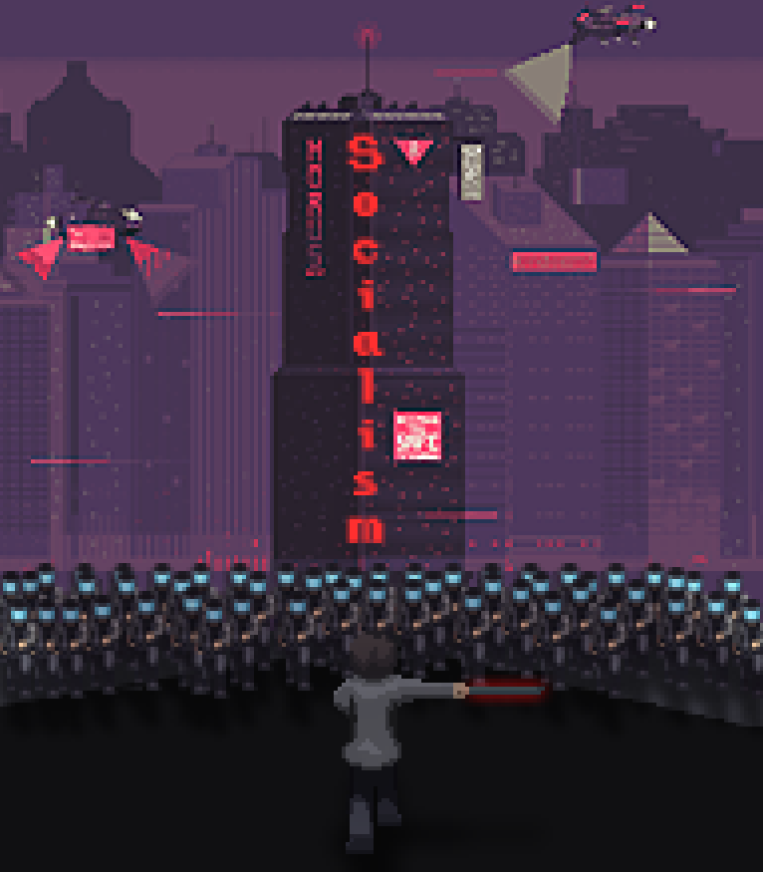

* 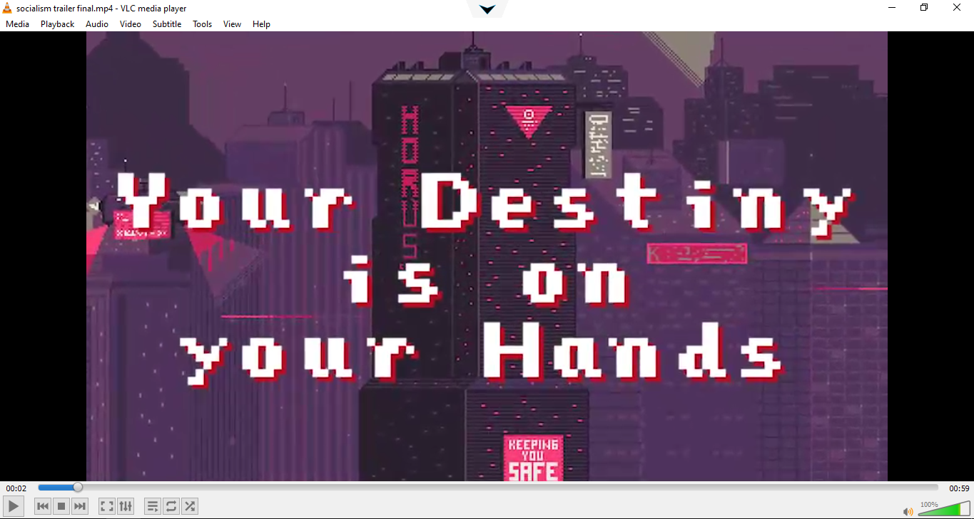Remake Trailer
* Create Cutscene and put it in the Unity

